CS 255 System Design Document Template

This template lays out all the different sections that you need to complete for Project Two. Each section has guidance to prompt your thinking. You will need to continually reference the interview transcript as you work to make sure that you are addressing your client’s needs. There is no required length for the final document. Instead the goal is to complete each section based on what your client’s needs are. Remove this note when you are finished, and replace all bracketed text with the relevant information.

UML Diagrams

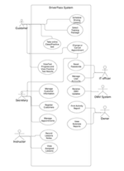
UML Use Case Diagram

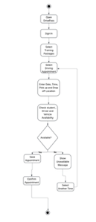
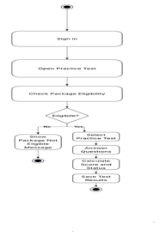
UML Activity Diagrams

UML Sequence Diagram
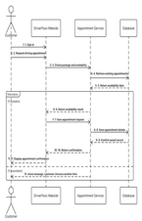

UML Class Diagram

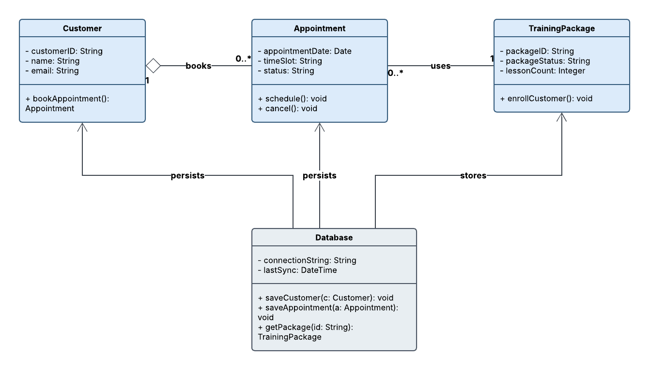

Technical Requirements
The Use Case Diagram shows who will use DriverPass and what they can do in the system. Customers can choose training packages, schedule driving lessons, change or cancel appointments, take online classes or practice tests, and check their test progress and results. Secretaries can register customers, update customer information, and manage appointments. Instructors can view their assigned lessons and record lesson notes. The owner can view business reports and print activity reports, while the IT officer can reset passwords and manage user accounts. The DMV System represents where DriverPass can receive outside updates. To support these features, DriverPass will need a website that works on computers, tablets, and smartphones. It will also need cloud hosting, a web server, supported web browsers, and a central database to store customer information, training packages, appointments, and test results.
The Activity Diagrams show the steps for scheduling a driving lesson and taking a practice test. When a customer requests a lesson, DriverPass needs to check whether the student, instructor, and vehicle are available at that time. If the time is already booked, the system will show a message and let the customer choose another time. If everything is available, the appointment will be saved and confirmed. Before a customer takes a practice test, the system will check whether the selected training package includes access to practice tests. After the customer finishes, DriverPass will calculate the score and save the result. The system will need enough processing capacity to handle these tasks and regular backups to help protect information if something goes wrong.
The Sequence Diagram shows how the customer, website, appointment service, and database work together when a driving lesson is scheduled. The customer sends an appointment request through the website. The appointment service then checks the customer’s package and looks for scheduling conflicts using information from the database. If the requested time is available, the system saves the appointment and sends a confirmation to the customer. If the time is unavailable, the customer is asked to select another time. These parts of the system need to communicate reliably so appointments are saved correctly. HTTPS and TLS will also be needed to protect information sent between the user’s device and the website.
The Class Diagram shows how DriverPass will organize information about customers, appointments, training packages, and other records. A database management system will be needed to store this information and keep related records connected. The database should support customer details, appointment dates and times, training package information, lesson counts, and practice test results. It should also support instructor assignments, vehicle information, lesson records, and activity logs. Lucidchart will be used to create the diagrams, while the programming tools, database software, and testing tools will be chosen during development.
DriverPass will also need security measures to protect customer information. Users must sign in to access the system, and employees should only be able to use the features needed for their jobs. Passwords must be stored securely, and the IT officer needs to be able to reset passwords and manage or disable accounts. Regular backups and a recovery plan will help protect information if the system fails. If customers purchase training packages online, DriverPass will need a secure payment provider. The system should also support receiving updated DMV rules, policies, and sample questions through an approved process. Direct automated communication with the DMV should only be included if an approved connection is available.
Overall, DriverPass will need cloud hosting, a website, a web server, a central database, secure user accounts, encrypted connections, and backup procedures. These resources will support the tasks customers and employees need to complete. The specific hosting provider, database technology, programming tools, payment provider, and performance targets will need to be decided before development begins. These requirements are based on the DriverPass business needs and are intended to help the system work reliably while keeping customer information protected.

